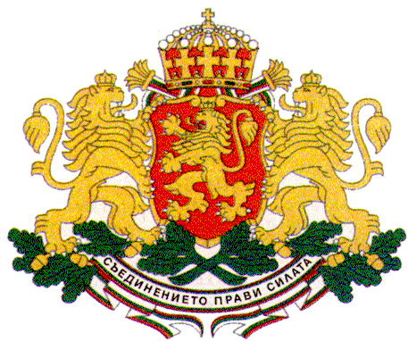 | PERMANENT MISSION OF THE REPUBLIC OF  BULGARIA  TO THE UNITED NATIONS

11 East 84th Street, New York, NY 10028, Tel: (212) 737 4790, Fax: (212) 472 9865, e-mail: bulgaria@un.int

UN Security Council Open Debate
Maintenance of international peace and security: Trafficking of persons in conflict situations
New York, 21 November 2017

H.E. Mr. Georgi Panayotov, Ambassador, Permanent Representative of Bulgaria to the UN

Mr. President,
I would like to thank Italy for organizing today’s Open Debate.
Bulgaria aligns itself with the statement made by the European Union.
Trafficking in persons is a grave human rights violation and a highly lucrative form of transnational organized crime with huge human, social and economic implications that requires a concerted global response. The problem is further exacerbated by conflicts and the ensuing large movements of refugees and migrants who often become easy targets of different forms of exploitation.
Bulgaria emphasizes the importance of accelerating the international cooperation to eliminate human trafficking through a comprehensive, multidisciplinary and cross-border approach. Better cooperation should be established among countries of origin, transit and destination on information sharing and victims’ identification, support and reintegration.
Bulgaria reaffirms its commitment to the implementation of the UN Convention against Transnational Organized Crime and the Palermo Protocols therein which constitute a solid foundation of international law in this area, as well as of Security Council Resolution 2331 of 2016.
Bulgaria highlights the importance of the new Resolution on trafficking of persons in conflict situations adopted unanimously today by the Council which Bulgaria has also cosponsored. Bulgaria welcomes the special emphasis that the new resolution puts on the protection of children and the strong language contained therein on children’s rights which is a key priority of the Government of Bulgaria.

Bulgaria was among the pioneers in Europe to adopt specialized anti-trafficking legislation back in 2003 and currently has one of the most comprehensive legal and institutional frameworks to combat trafficking in persons. Bulgaria has penalized trafficking in persons and has introduced more severe punishment for crimes involving children. The Bulgarian legislation includes provisions allowing that victims of trafficking are not penalized for their involvement in unlawful activities in which they have been compelled to engage.
The Government of Bulgaria has established a National Referral Mechanism for Support of Trafficked Persons with the aim to further strengthen the respect for human rights of victims of trafficking by providing them with unconditional support and protection, following the principle of non-discrimination.
The National Anti-Trafficking Strategy of Bulgaria for 2017 – 2021 follows a victim-centered, human rights-based, gender-specific and child-focused approach.
The National Commission to Combat Trafficking in Human Beings, which coordinates the state policy in this priority area, provides assistance to victims of trafficking in Government funded shelters across the country. A specialized shelter for children was established earlier this year to ensure better protection of children victims of trafficking through the provision of specially designed integrated services for children, including psychological, social, medical and legal support, assistance and social reintegration.
In recent years Bulgaria has increased its capacity to ensure the rights of victims of trafficking with a special focus on children, and has stepped up its participation in international efforts to fight this crime. Special measures are taken to raise public awareness, particularly among children, in partnership with local authorities, civil society and youth volunteers.

Thank you, Mr. President!

